BSAN 450 Assignment 10

The data for this assignment is the monthly Minneapolis public drunkenness intakes from January 1966 to July 1978. The data is in the a file named Drunkintakes.csv and the variable name is Intakes.

Read the data into RStudio and find a time series model that you believe fits the data appropriately.

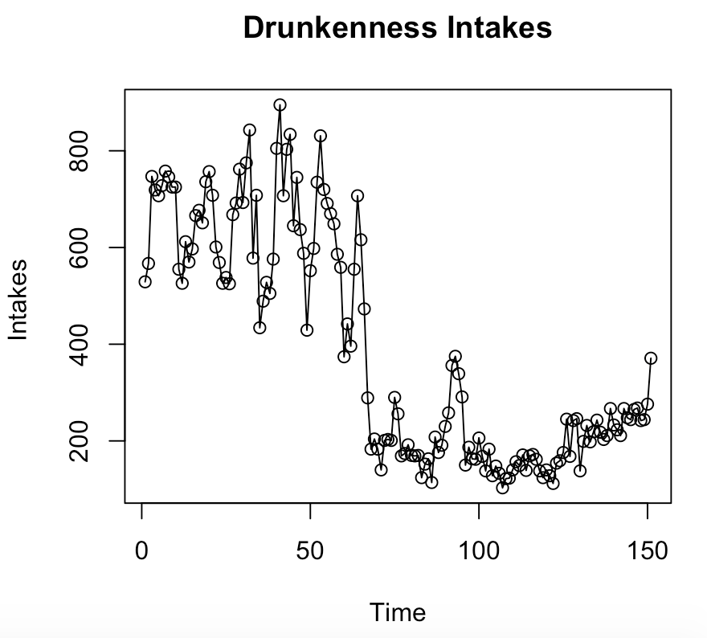

**This plot does not look stationary. The variance is increasing with time and the mean is not constant.**

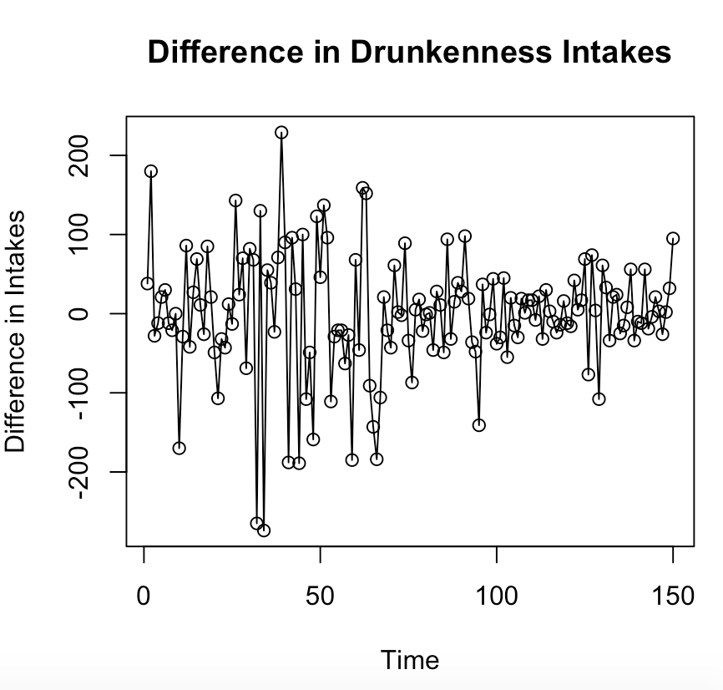

**This looks better and appears to be stationary time series.**

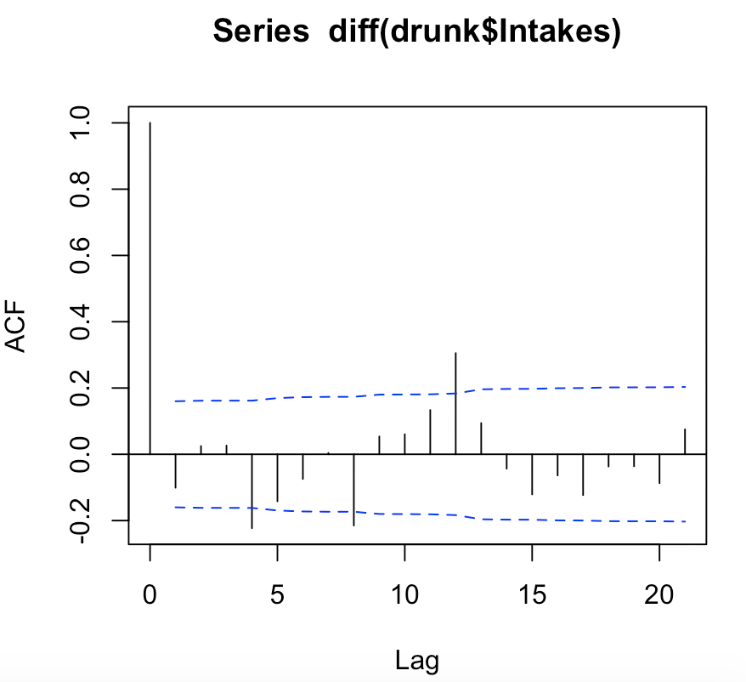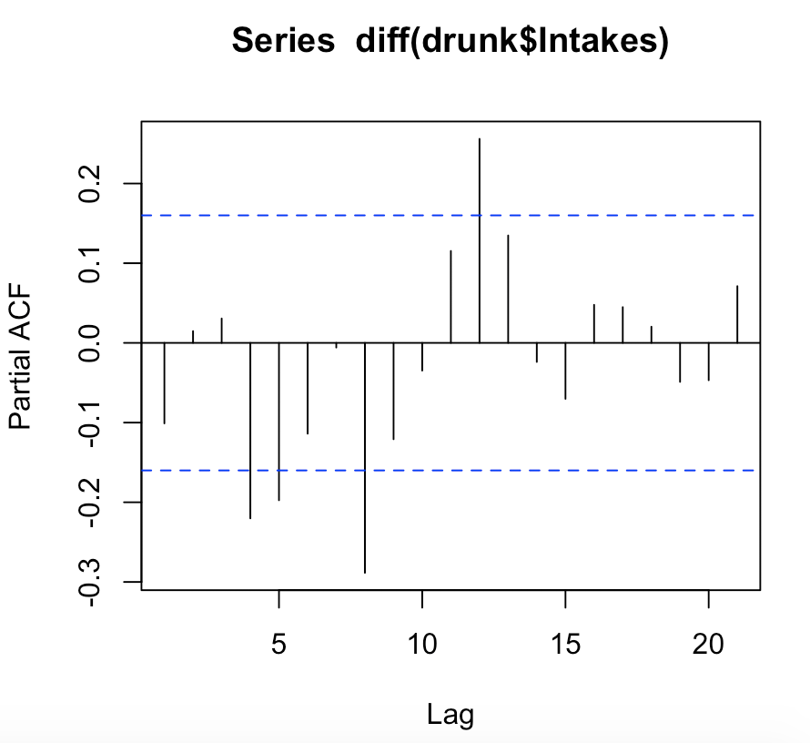

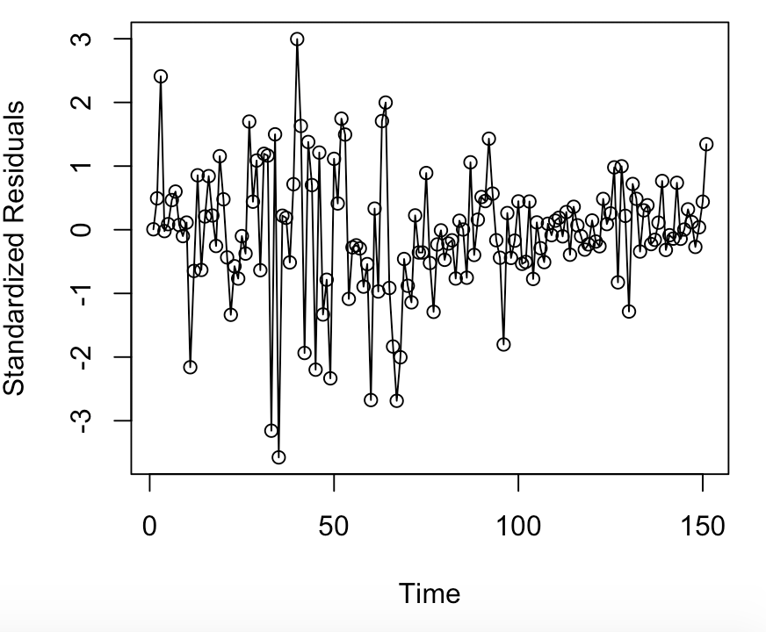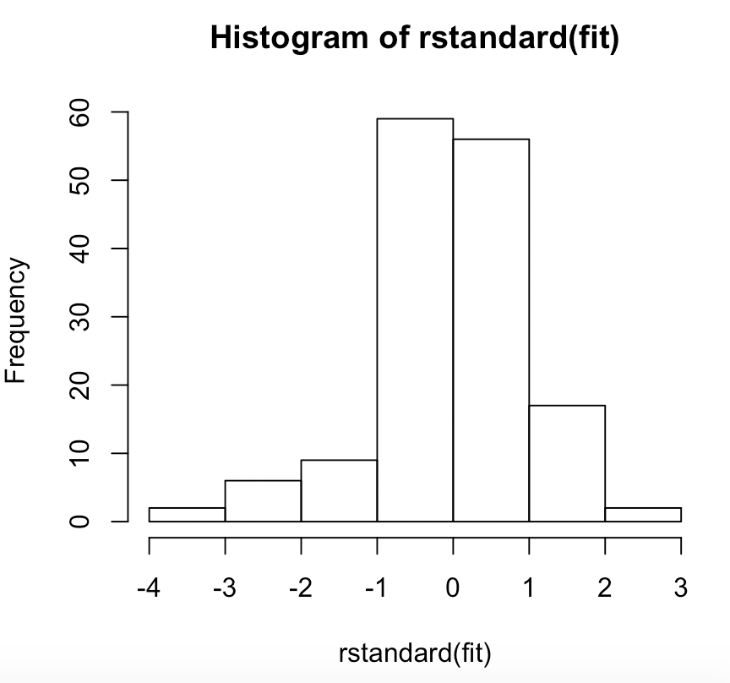

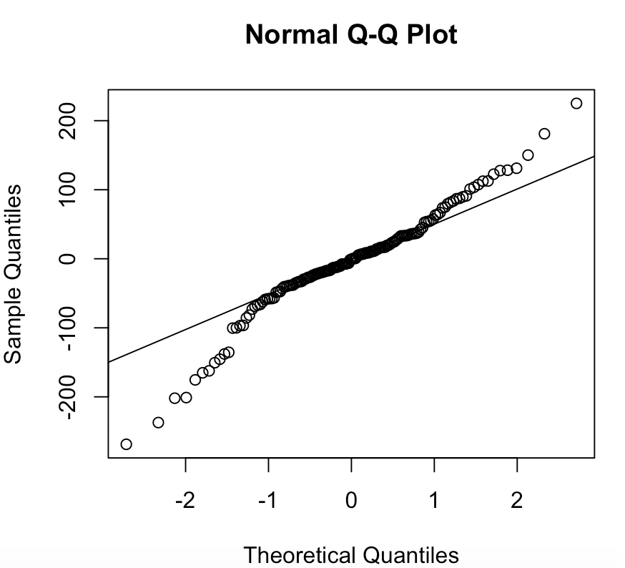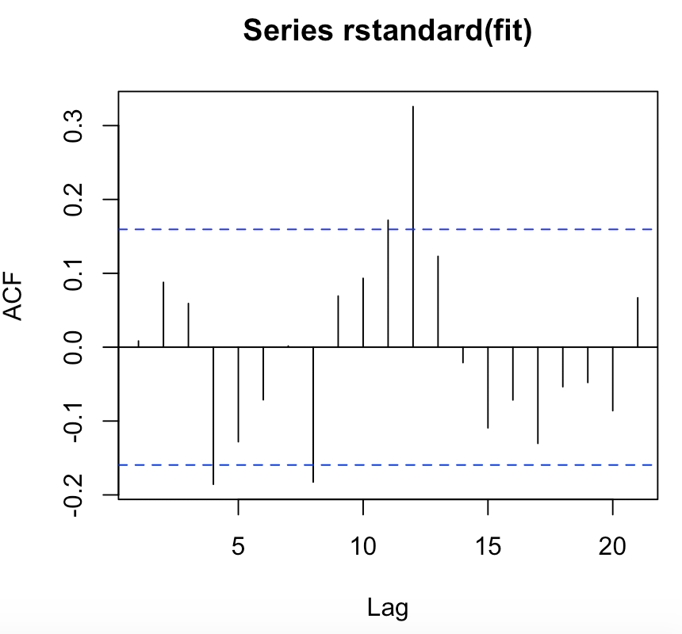

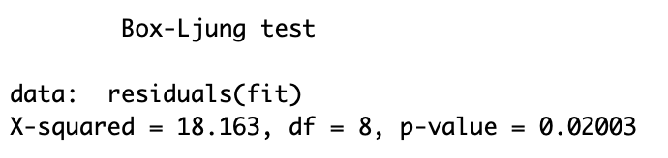

**The diagnostics suggest that there are outliers and that a transformation is needed.**

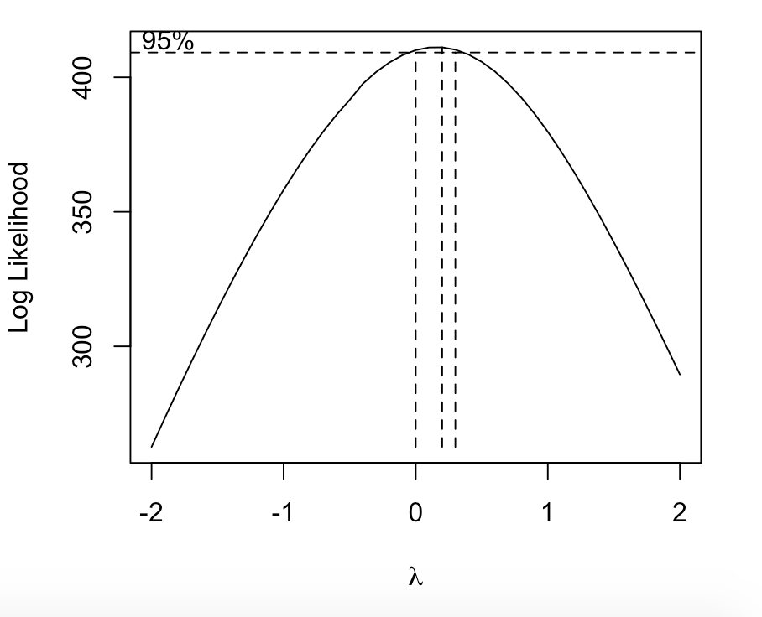

**This indicates a need for a log transformation.**

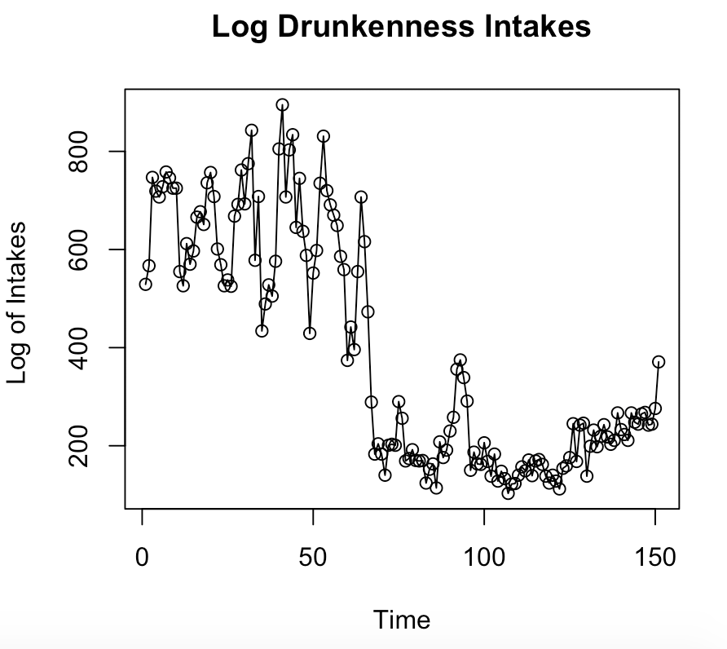 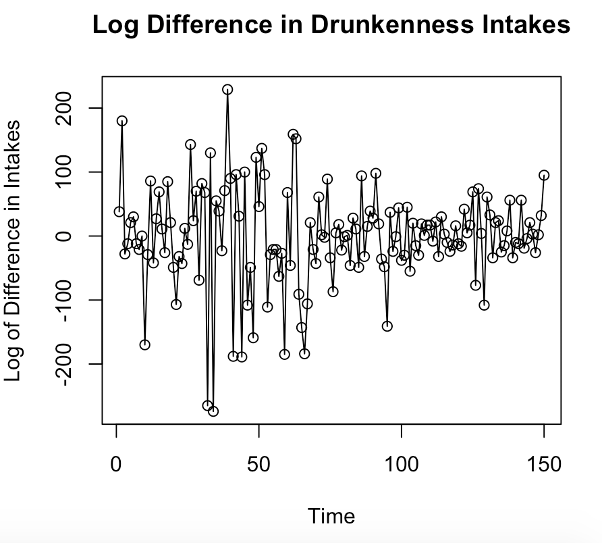

**The log of intakes does not look stationary. The variance is increasing, and the mean is not stationary. The log of the differences looks better but the variance looks like it is increasing.**

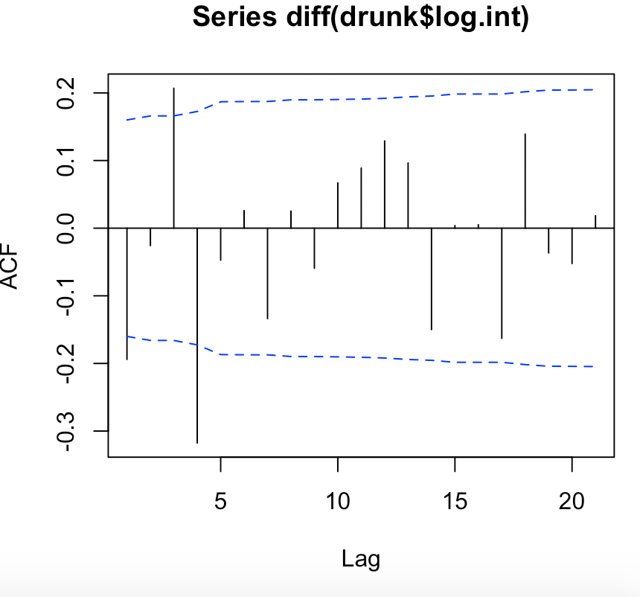 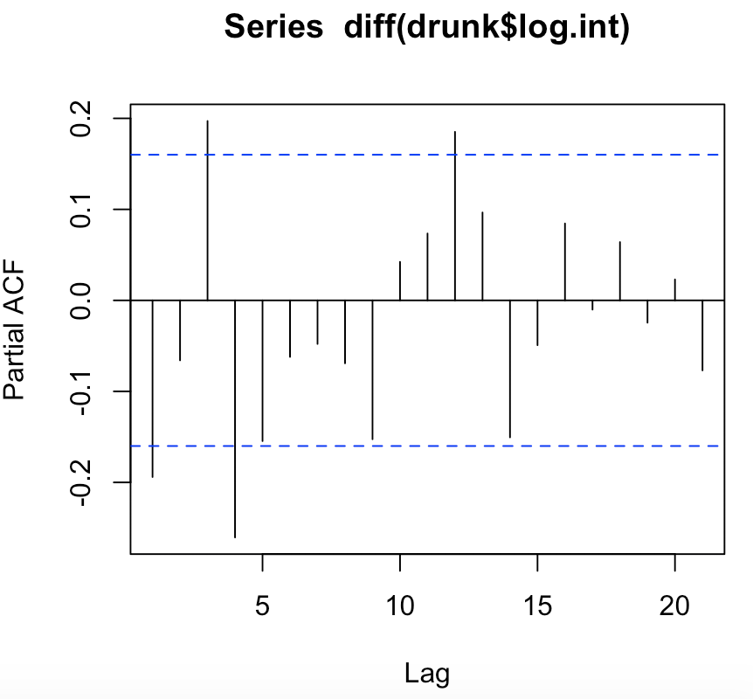

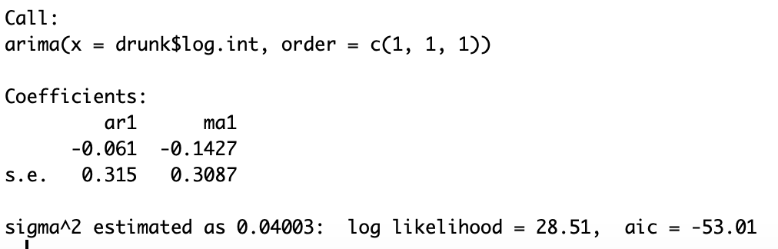

**Tried the ARMA(1,1) model but the coefficients are not significant.**

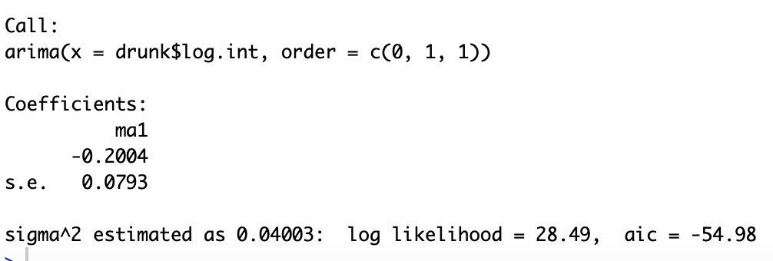

**A MA(1) model fits better. The coefficient is significant.**

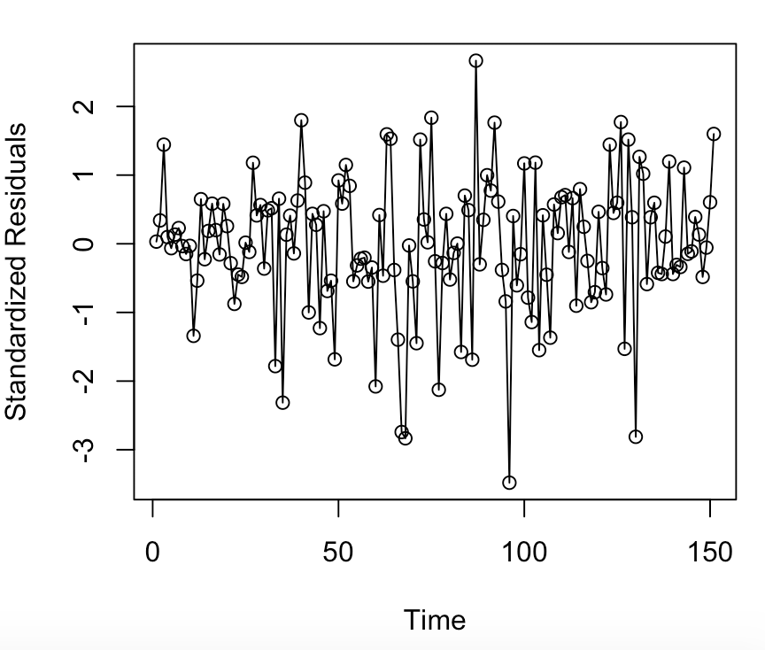 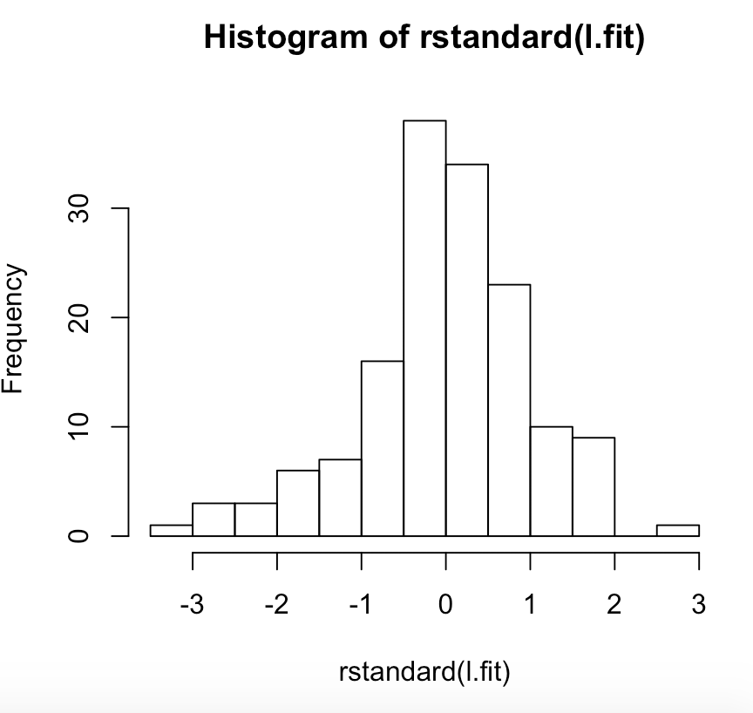

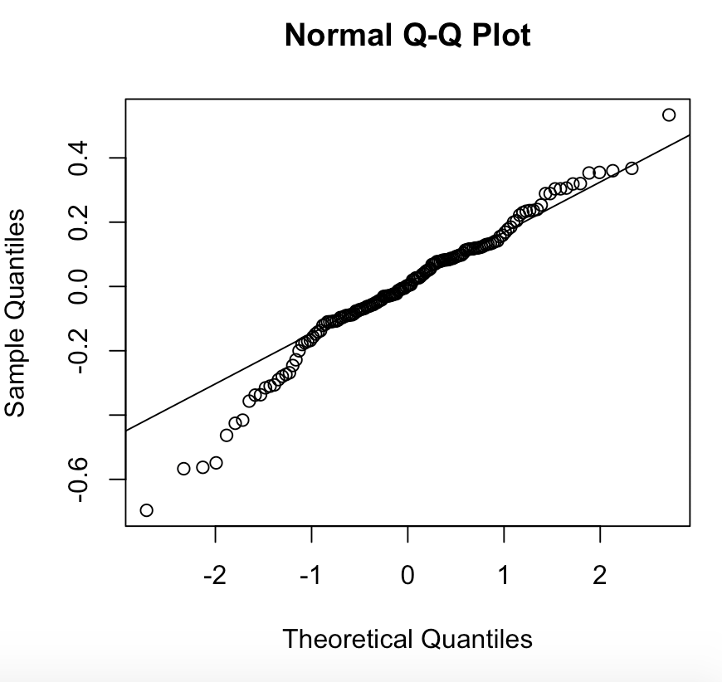 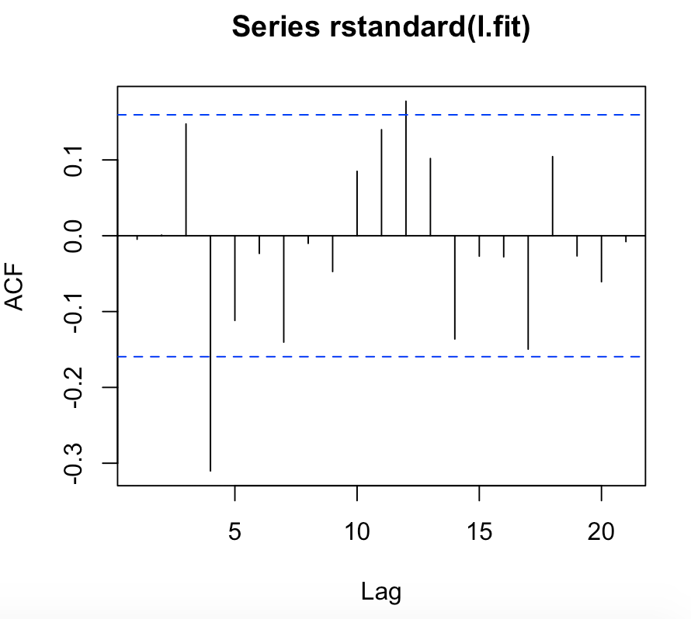

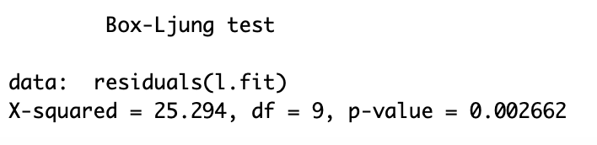

**These diagnostics indicate an issue because the p-value is too small.**

**Based off the two different models I have tested the best fit for the data is a ARMA(1,1) for the difference in the intakes. Below is that model**

